**DAY 2 ASSIGNMENT – 7**

**Detailed Summary of Different Project Methodologies**

1. **Waterfall Model:**

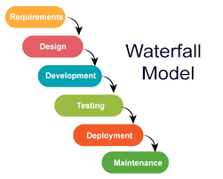

* **How it works:** The project flows downwards through distinct phases like a waterfall — starting with requirement gathering, then design, implementation, testing, and finally deployment.
* **Pros:** Easy to understand and manage, works well when requirements are fixed and clearly defined.
* **Cons:** Difficult to accommodate changes once the project moves past a phase; late testing can lead to discovering issues late.
* **Best for:** Projects with stable requirements, such as construction or manufacturing.

1. **Agile Methodology:**

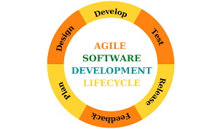

* **How it works:** Divides the project into small cycles called sprints (usually 1-4 weeks), delivering working parts frequently.
* **Pros:** Highly flexible and adaptive to change, promotes continuous feedback and improvement.
* **Cons:** Requires active customer involvement and disciplined teams.
* **Best for:** Projects with evolving requirements, such as software development.

1. **Spiral Model:**

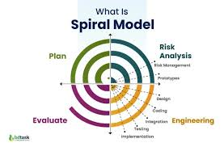

* **How it works:** Combines iterative development with risk assessment. The project cycles through phases of planning, risk analysis, engineering, and evaluation repeatedly, improving each time.
* **Pros:** Focuses on early identification and mitigation of risks, good for complex projects.
* **Cons:** Can be costly and complex to manage.
* **Best for:** Large, high-risk projects like aerospace or defence.

1. **Scrum Model:**

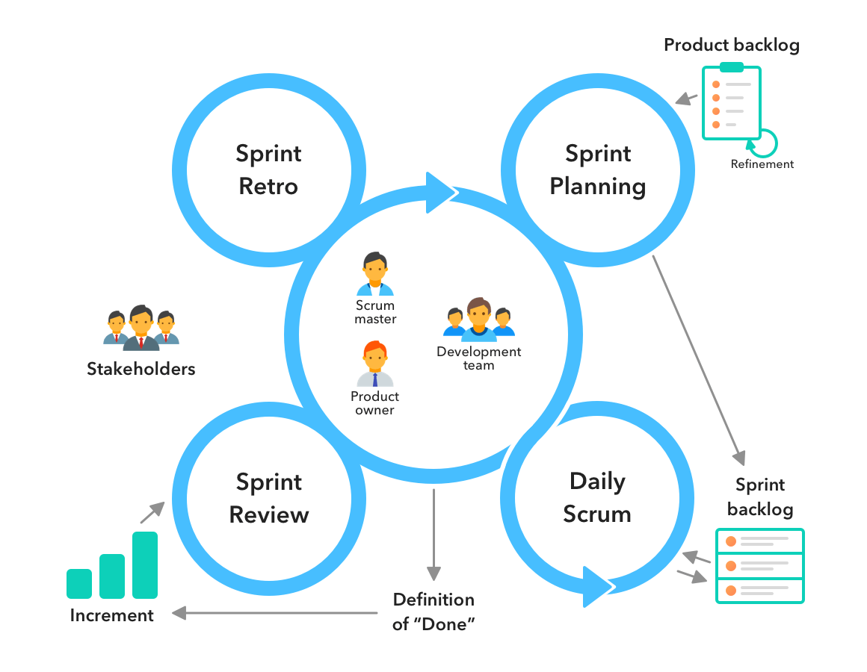

* **What is it?** A way to manage projects in short work cycles called **sprints** (usually 2-4 weeks).
* **How it works:** The team plans what they can finish in each sprint, meets daily to check progress, and shows their work at the end.
* **Why use it?** It helps teams deliver work quickly, stay organized, and improve continuously by getting feedback often.

1. **Kanban Model:**

A visual way to track work using a **board** with columns like “To Do,” “Doing,” and “Done.”

